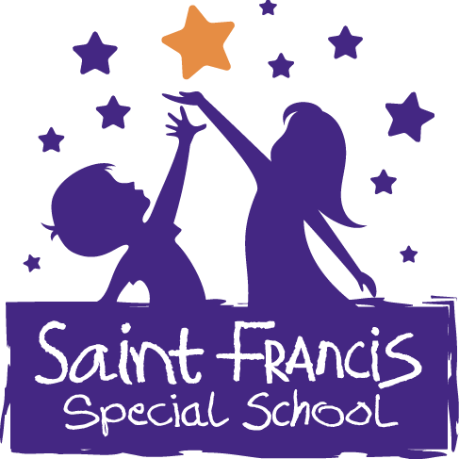
St. Francis Special School
Fón/Fax: 0646644452 www.sfss.ie
Email: info@sfss.ie Roll:19547E

Policy Document on Peg Feeding

Purpose
This policy was drawn up to ensure best practises are in place in the administration of PEG feeding and to provide clear guidance for staff on the safe management of PEG feeding.

The following guidelines will be adhered to by staff:
- The principal will ensure staff are trained and confident in the administration of PEG Feeding and that staff can recognise and know how to appropriately respond to actual and potential risks associated with this type of feeding

- All relevant staff are trained to ensure competence and safety in PEG feeding. Further training has been requested for SNAs. The nurse in the school has been trained in PEG feeding in 2022. Staff received training from Nutricia in October 2016 and refresher training - September 2018.

- Staff have clear guidelines for each child's PEG feeding – these guidelines are provided by the child's Dietician and will be on display in the classroom. instructions from parents are also noted.

- Staff will maintain an accurate record of the child's prescribed PEG Feeding regime and will record PEG Feed on checklist

- Permission for staff to administer PEG Feed is included in the consent forms as relevant. All PEG feeding equipment is serviced in accordance with the manufacturer’s specifications. It is the responsibility of the parents/guardians to ensure equipment is checked, cleaned, stored and maintained correctly. Feed pumps must be calibrated every 2 years (check dates).

- ENPLUG’s to be sent in pupils bag if prescribed to the child – (if not kept at school). In case of emergency ENPLUG will be inserted only by a school nurse.

- Staff will follow the Paediatric Home Tube Feeding Guide from Nutricia to ensure best practices. All staff are to ensure they are up to date in training in hand hygiene and infection prevention and control.

Review and Ratification
This policy was ratified by the Board of Management of St. Francis Special School on_____________

The policy will be reviewed regularly in the light of experience. It will be reviewed by the full staff and Board of Management every two years. Next review of this policy will occur during the school year of 2023/2024.

Signed: Signed: ____________________

Chairperson:_____________________ Principal: __________________

Date: Date: ___________________

