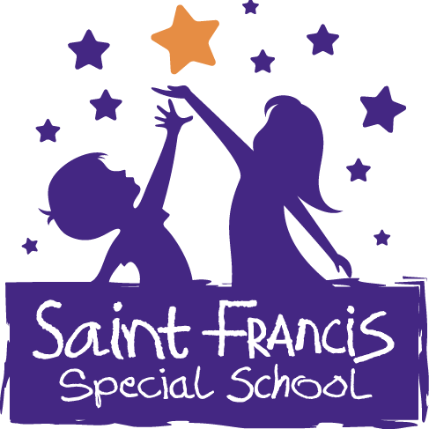

Wellbeing Policy

Introductory Statement and Rationale

St. Francis Special School is a special school which caters for pupils with Moderate and or Severe to Profound Intellectual Disability. We endeavour to cater for the holistic needs of each pupil through Individual Education Planning. We have written this school plan to ensure an approach which supports transition from class to class throughout the school. Our school advocates a whole school approach to the planning process and all relevant parties, staff, parents, and pupils, were part of the development of our school plan for Wellbeing.

School Vision

St. Francis Special School endeavours to nourish the educational, social, emotional, spiritual and physical development of each student to his/her potential with the future expectation of active participation in his/her local community. St. Francis Special School endeavours to promote the wellbeing of students by:
- Being child centred.
- Being sensitive to the reality of our children’s lives in a changing world.
- Providing a safe and healthy environment.
- Promoting positive health behaviour.
- Increasing knowledge about Health, Relationships, and Sexuality.
- Promoting self-esteem and self-awareness of students.
- Working in partnership with the parents and pupils.

Overall aims of this policy

Our Wellbeing programme aims to foster happy, confident, responsible and resilient students who feel connected to St. Francis school and his/her local community. We have embraced a whole-school approach and aligned the design and planning for our Wellbeing programme with School Self-Evaluation.
Our Wellbeing programme is anchored in the following subject areas: Junior Cycle Level 2 Learning Programme PLUs Personal Care (SPHE), Living in the Community (CSPE) PE and other Units of Learning. Junior Cycle Level 1 Learning Programme PLUs Personal Care and Wellbeing (SPHE), Being part of a Community (CSPE) PE,

and other Units of Learning. Other Units of learning will cover topics related to CSPE, SPHE, PE, IT, Home Economics, Religion, meditation and mindfulness etc.
The emphasis of this policy is on the role of the whole school community in the wellbeing programme. This is a whole school policy and the following school policies will be informed by it:

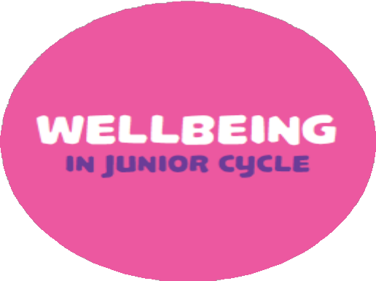
  - Behaviour Policy
  - Homework Policy
  - SPHE Policy
  - RSE Policy
  - Internet Safety Policy
  - Anti-bullying Policy
  - Dignity in the Workplace Policy
  - Child Protection Policy
  - Critical Incident Policy
  - Healthy Eating Policy

Content of Plan

There are 6 key indicators of Wellbeing.

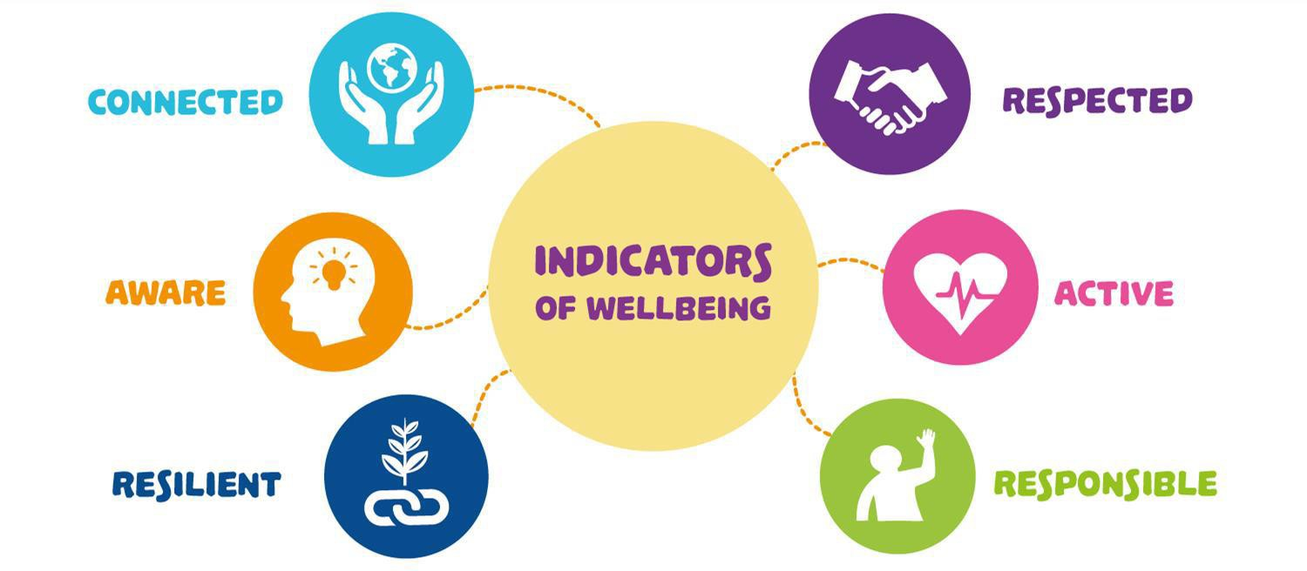

Wellbeing contributes directly to students’ physical, mental, emotional and social wellbeing and resilience. Student wellbeing is present when students realise their abilities, take care of their physical wellbeing, can cope with the normal stresses of life, and have a sense of purpose and belonging to a wider community. There is overwhelming evidence that students learn more effectively, including their academic subjects, if they are happy in their work, believe in themselves, their teachers and feel school is supporting them.

Scope of the Wellbeing Policy

- Explore current and future avenues for fostering happy, confident, responsible and resilient students who feel connected to St. Francis Special School.
- Reflect on how we are currently addressing the area of Wellbeing in our school through curricular and extra-curricular provision.
- Comply with DES Circular Letter 0055/2019 which mandates 400 hours of Wellbeing to be included in the timetable over the 3-year cycle from September 2020.
- Consider the voices of key stakeholders, namely staff, parents, students and Board of Management. Engage in an extensive process of consultation to ensure that the voices and input of the whole school community are valued.
- Demonstrate an awareness of our unique school context, our characteristic spirit and the values underpinning our mission statement.
- Adopt an open, transparent and consultative approach to the implementation of a Wellbeing Programme. We are cognisant of the necessity to constantly plan, review and reflect, three premises also inherent in School Self Evaluation (SSE).
- Support the consultation process and use feedback to inform the curricular plan for Wellbeing. Explore the full spectrum of innovative curricular possibilities for Wellbeing, aligned to the identified subject areas, PE, Personal Care (SPHE) Living in the Community (CSPE), and other units of work.

Wellbeing Curriculum Plan

Class  Subject | First Year | Second Year | Third Year | Hours
PE | 2 class periods | 2 class periods | 2 class periods | 135 hrs
Personal Care (SPHE) | 2 class periods | 2 class periods | 2 class periods | 135 hrs
Living in the Community (CSPE) | 1 class period | 1 class period | 1 class period | 70 hrs
Other Units of learning (Relating to CSPE, SPHE,  PE, IT, Home Ec. and Religion | 2 x 5-week units, one period per week | 2 x 5-week units, one period per week | 2 x 5-week units, one period per week | 70 hrs
Whole-school activities over the three years |  |  |  | 35 hrs
*** Short courses in a variety of topics related to wellbeing are in the process of being developed and will form part of our Wellbeing Programme once completed |  |  |  | 445 hrs

Wellbeing in the Context of the Framework for Junior Cycle

The Junior Cycle Wellbeing Guidelines (2017, p.44) state that when planning a programme, the starting point must be the shared vision and values of the school alongside consideration of the principles and statements of learning set out in the Framework for Junior Cycle (2015).
A Junior Cycle programme that builds the foundations for Wellbeing:

- is broad and balanced

- provides choice
- has meaning and relevance
- is enjoyable and engaging
- provides opportunities to experience challenge and success
- equips students with the knowledge, skills and dispositions to develop as learners and build positive relationships.

The vision for Junior Cycle places students at the centre of all endeavours,
“Junior cycle places students at the centre of the educational experience, enabling them to actively participate in their communities and in society and to be resourceful and confident learners in all aspects and stages of their lives“, (Framework for Junior Cycle, 2015, p.6).

Wellbeing is one of the eight principles underpinning the Junior Cycle Profile of Achievement (JCPA)
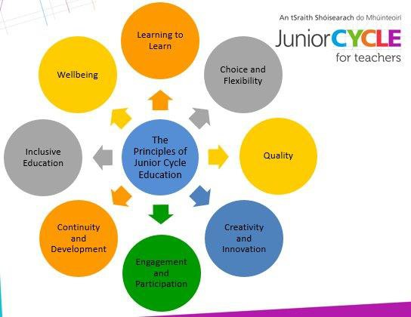

24 Statements of Learning

“The learning at the core of junior cycle is described in twenty-four statements of learning …. They are central to planning for, the students’ experience of, and the evaluation of the school’s junior cycle programme” (Framework for Junior Cycle, 2015, p.).

The purpose of learning statements

- To ensure a rich educational experience for students.
- Learning that has both breadth and depth and is varied.
- To enable development of the key skills.
- To give access to a varied curriculum of knowledge

The following Statements of Learning are particularly applicable to Wellbeing:

- The student has an awareness of personal values and an understanding of the process of moral decision making (SoL 5)
- The student values what it means to be an active citizen, with rights and responsibilities in local and wider contexts (SoL 7)
- The student has the awareness, knowledge, skills, values and motivation to live sustainably (SoL 10)
- The student takes action to safeguard and promote her/his wellbeing and that of others (SoL 11)
- The student is a confident and competent participant in physical activity and is motivated to be physically active (SoL 12)
- The student understands the importance of food and diet in making healthy lifestyle choices (SoL 13).

Key Skills

Staying Well is one of the 8 key skills for Junior Cycle.

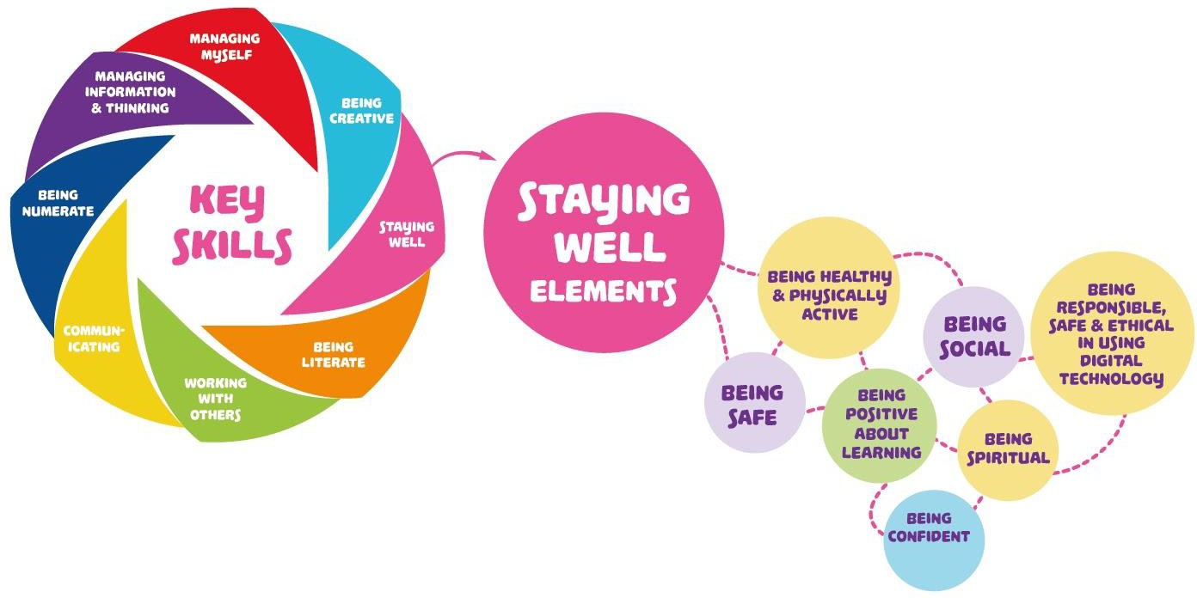

Elements of the Key Skill Staying Well are:

- Being healthy and physically active
- Being social
- Being safe
- Being spiritual
- Being confident
- Being positive about learning
- Being responsible, safe and ethical in using digital technology

Elements of other Key Skills that also relate to Wellbeing:

- Developing good relationships and dealing with conflict
- Respecting difference
- Contributing to making the world a better place
- Knowing myself
- Making considered decisions
- Setting and achieving personal goals.

“Key skills will be embedded in the learning outcomes of every junior cycle subject and short course” (Framework for Junior Cycle, 2015, p.15). Key skills help learners develop the knowledge, skills and attitudes to face the many challenges in today’s world. They also support students in learning how to learn and take responsibility for their own learning.

Our School Context and the Four Aspects of Wellbeing

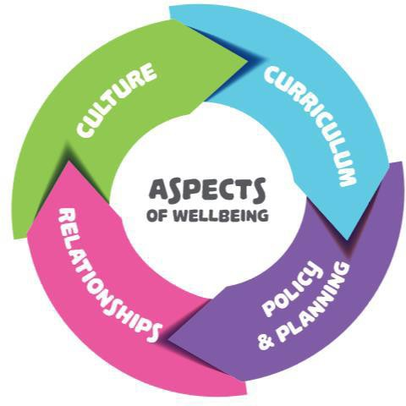

St. Francis special school is a school which, caters for pupils with Mild General Learning Disability. We endeavour to cater for the holistic needs of each pupil through Individual Education Planning. Caring and compassionate inter-personal relationships are fostered with students, staff, parents and the wider school community. We value the importance of a holistic education and nurturing our students to reach their full potential, celebrating moments of success and encouraging all students to grow and develop as individuals with unique talents and a strong sense of self-worth. Respectful and caring relationships between staff and students are evident in daily interactions and in the classroom.
St. Francis Special School endeavours to nourish the educational, social, emotional, spiritual and physical development of each student to his/her potential with the future

expectation of active participation in his/her local community. St. Francis Special School endeavour to promote the wellbeing of students by:
- Being child-centred.

- Being sensitive to the reality of our children’s lives in a changing world.

- Providing a safe and healthy environment.

- Promoting positive health behaviour.

- Increasing knowledge about Health, Relationships, and Sexuality.

- Promoting self-esteem and self-awareness of students.

- Working in partnership with the parents and pupils.

There are structures in place designed to support the wellbeing of our students. We have a strong pastoral care system, with clear channels of support for students’ wellbeing, including class teachers, classroom assistants, the Principal and Deputy Principal. The school has links with external agencies that support the wellbeing of pupils including
- Jigsaw
- CAMHS
- KIDS

Students know where to get support and how to access the ‘care’ structures in the school. Students feel safe, secure and respected in St. Francis Special School. There is a positive behaviour policy where discipline issues are resolved with care, respect and consistency.
Student learning and wellbeing are inextricably linked, students learn best when their wellbeing is optimised, and they develop a strong sense of wellbeing when they experience success in learning. We have a highly dedicated teaching staff with vast expertise, all of whom are committed to maintaining excellence in teaching and

learning. All staff contribute to promoting a caring and inclusive environment within the school that is supportive of student wellbeing.
We provide a broad and balanced curriculum to afford students’ opportunities to achieve success in accordance with their talents, abilities and interests. We offer Junior Cycle Learning Programme Level 1 & 2, and the Leaving Certificate Applied (LCA) Programme.
Explicitly planning for wellbeing in the curriculum and assigning it space on the timetable communicates to students, parents and teachers that this area of learning is important – it makes the school’s concern with wellbeing visible and confirms for students in a very recognisable way that their wellbeing matters. For this reason, the 2017 Wellbeing Guidelines place a strong emphasis on the role that Civic, Social and Political Education (CSPE), physical education (PE), Social, Personal and Health Education (SPHE), guidance and other units of learning can play in supporting learning about wellbeing and learning for wellbeing.

Review and Ratification

This policy was ratified by the Board of Management

Chairperson’s signature:

Principal’s signature:

Review Date:

